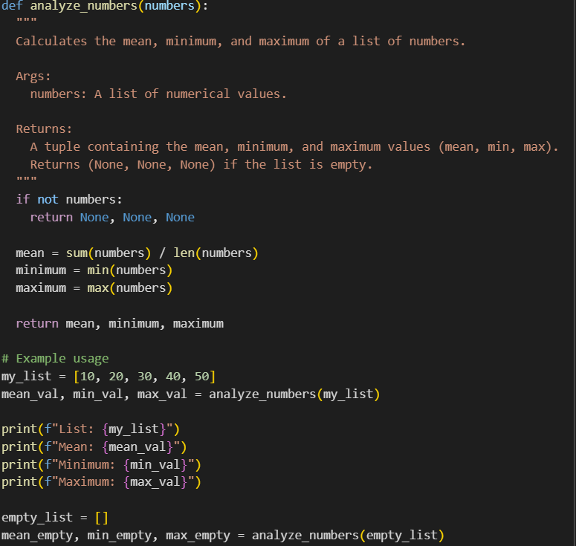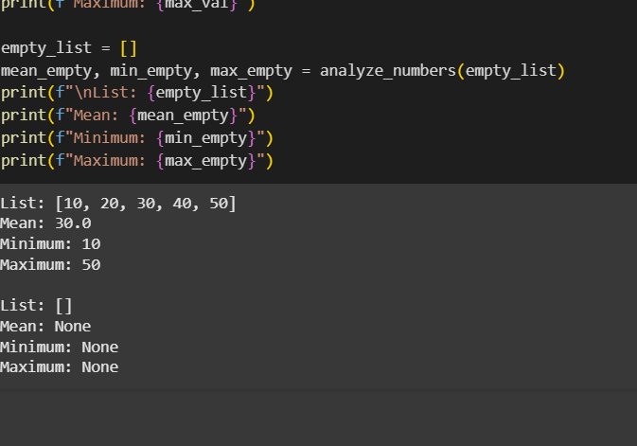

Task Description #2

Compare Gemini and Copilot outputs for a Python function that checks whether a number is an Armstrong number. Document the steps, prompts, and outputs

This is the code and output given by gemini ai:

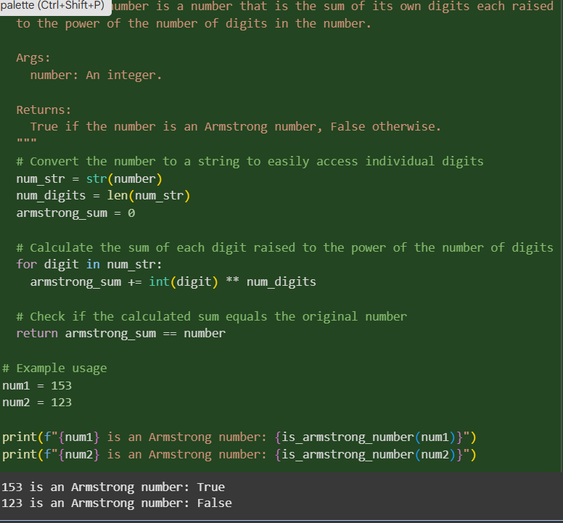

This is the code and out out given by Microsoft copilot

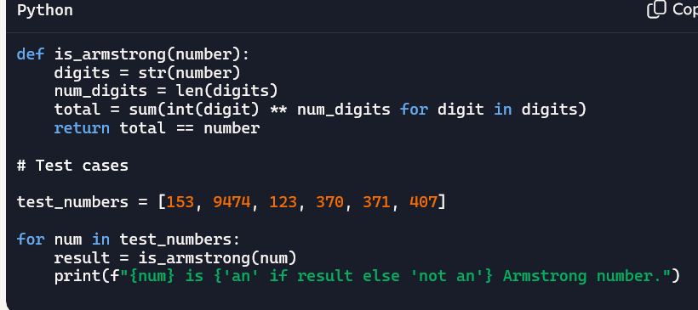

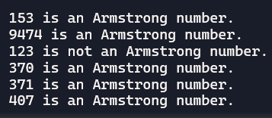

Task Description #3

* Ask Gemini to explain a Python function (e.g., is_prime(n) or is_palindrome(s)) line by line.

Out put: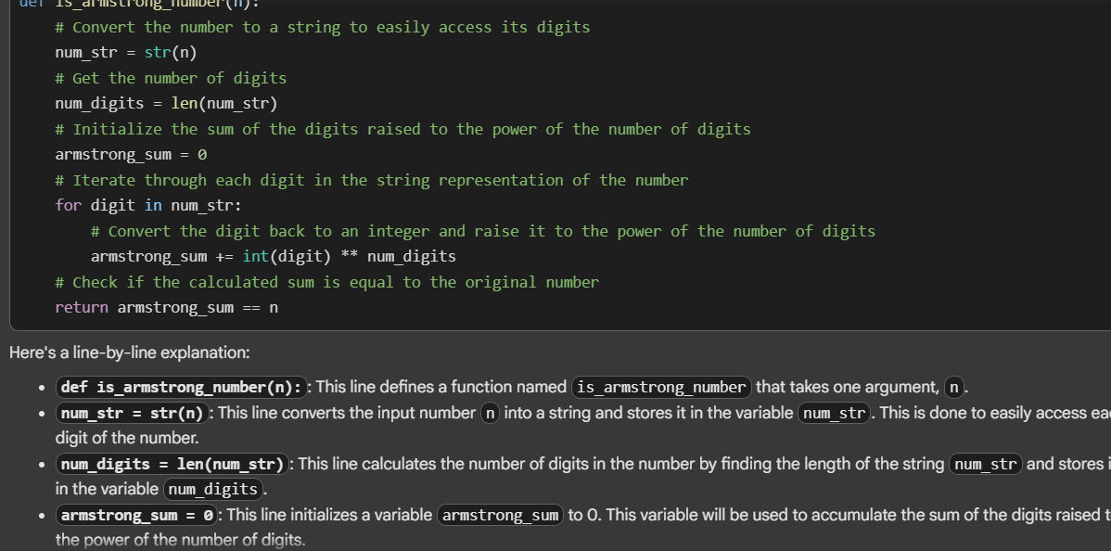

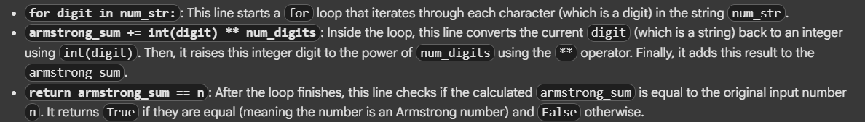

Task Description #4

* Install and configure Cursor AI. Use it to generate a Python function (e.g., sum of the first N natural numbers) and test its output.
* Optionally, compare Cursor AI’s generated code with Gemini’s output.

Out put: this is the cursor ai output

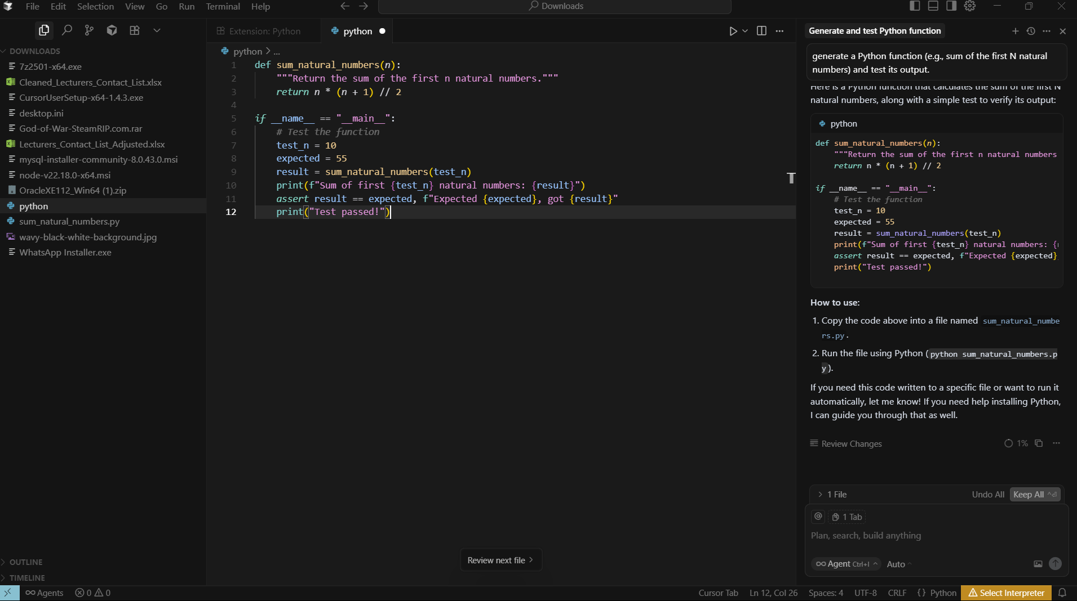

COMPARING CURSOR WITH GEMINI AI :

IN MY OPINION GEMINI AI UNDERSTANDS THE PROMPT COMPLETELY AND GIVES THE OOUTPUT TOO.

